Test Plan Document

Unit Test library for C# => xUnit

Test Cases 5

============================================================================

Test Case 1 - TestValidateDigit

This test intentions is to make sure the method has fulfil the expected input as digit only

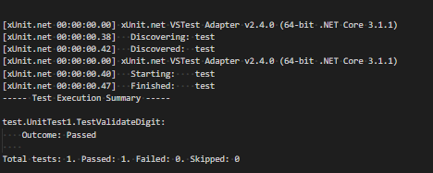

============================================================================

Test Case 2 - TestGetTeensMaps

This test intention is to make sure the unit of Teens already fulfil the expected result

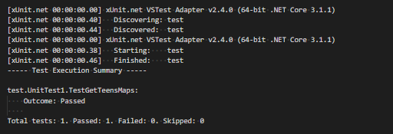

============================================================================

Test 3 - TestGetHundred

This test intention is to make sure the unit of Teens already fulfil the expected result 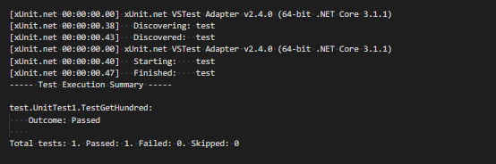

============================================================================

Test 4 - TestGetCents

This test intention is to make sure the number of cents already fulfil the expected result

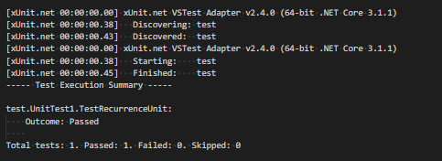

============================================================================

The whole test result

